User Documentation

Contents

Installation 2

Use 4

Students 4

Inputting availability 4

Staff 5

Inputting availability 5

Admin 6

Imputing availability 7

Importing student, staff and lesson data. 8

Setting day settings 9

Resetting DAT files. 11

Generating appointments 11

Sending everyone their appointments 12

# Installation

When the CD has been put into the computer this is what will be in side.

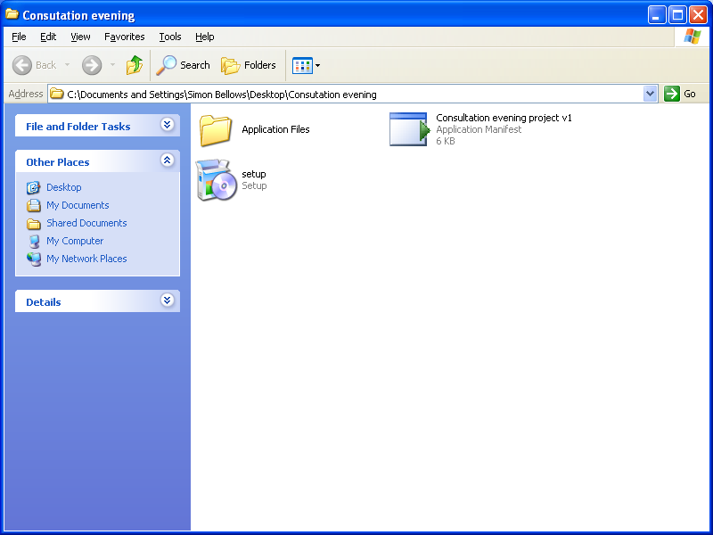

The user then has to double click setup. At which point they will see this.

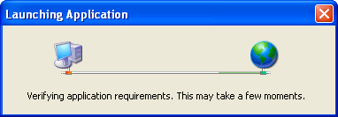

Once it has loaded the user then has to click Install

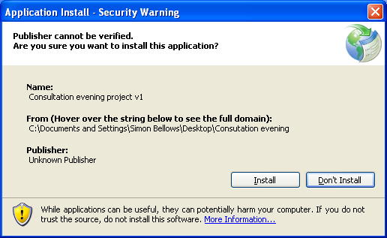

The program will not be accessible via all programs

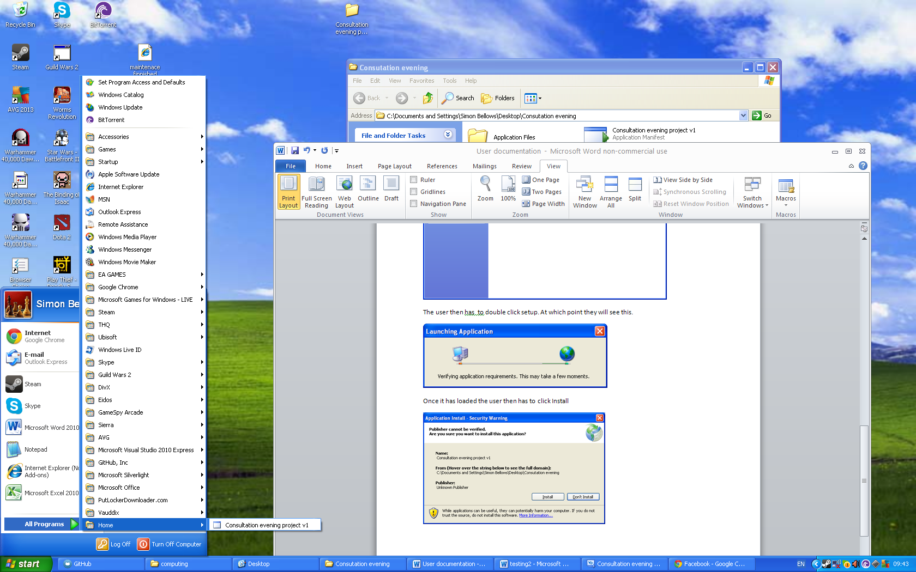

It will also be found in program files where it can be exported to where it is needed.

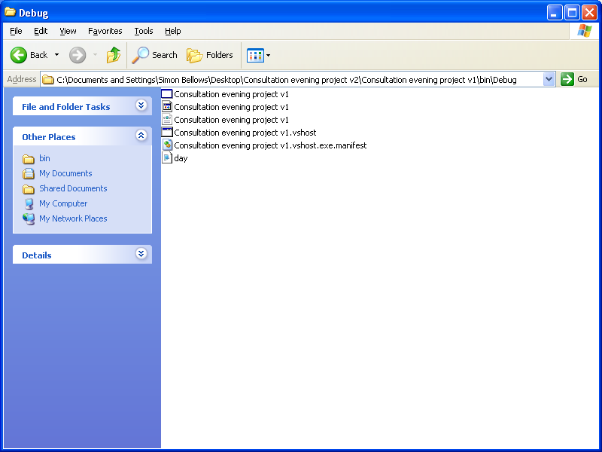

# Use

## Students

When students open the application they will be met with:

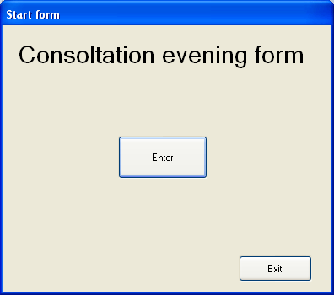

To leave the application they press Exit

To continue on to input their availability they click enter

### Inputting availability

They will be met with a window that looks like this

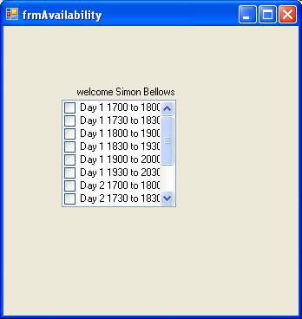

They will then check the times they are available for by checking the checkbox on the left of each item in the list. This will cause the program to look like this.

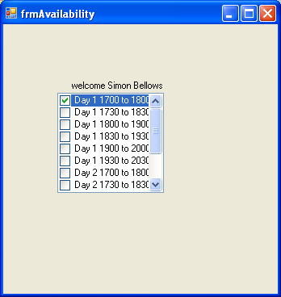

They will then coninue checking boxes untill they are finnished and have input every thing they wish to. At which point they can hit the x to leave the applicatin as it updates imdiatly after checking a box.

## Staff

When non admin staff open the application they will be met with:



To leave the application they press Exit

To continue on to input their availability they click enter

### Inputting availability

They will be met with a window that looks like this



They will then check the times they are available for by checking the checkbox on the left of each item in the list. This will cause the program to look like this.



They will then coninue checking boxes untill they are finnished and have input every thing they wish to. At which point they can hit the x to leave the applicatin as it updates imdiatly after checking a box.

## Admin

When students open the application they will be met with:

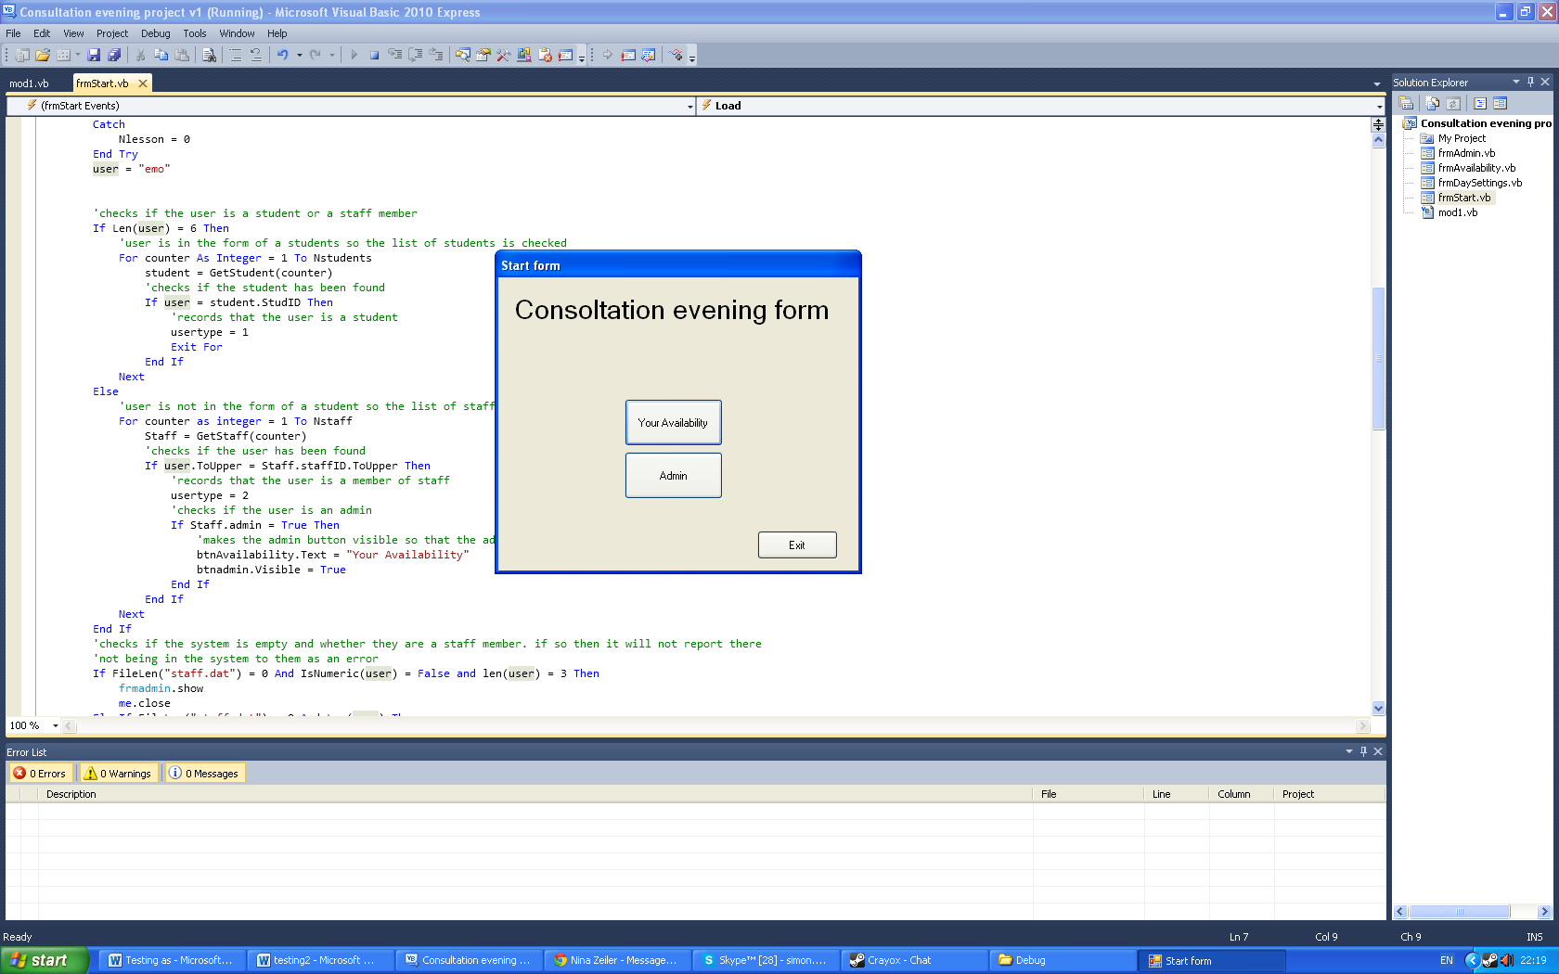

To leave the application they press Exit

To continue on to input their availability they click enter

### Imputing availability

They will be met with a window that looks like this



They will then check the times they are available for by checking the checkbox on the left of each item in the list. This will cause the program to look like this.



They will then coninue checking boxes untill they are finnished and have input every thing they wish to. At which point they can hit the x to leave the applicatin as it updates imdiatly after checking a box.

If they had clicked on the admin button they would have been sent to

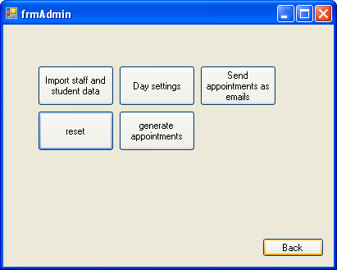

### Importing student, staff and lesson data.

The admin have to first remove the top row off the tutor, classslots student and studentclass sheets in the MIS Excel document. They then have to save these as CSV’s (comma separated variables.). they then have to move these to the folder containing the program.

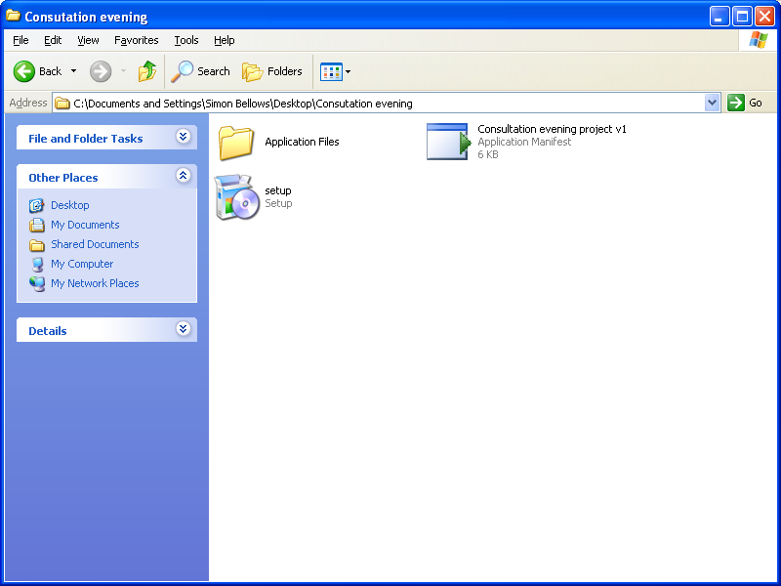 to 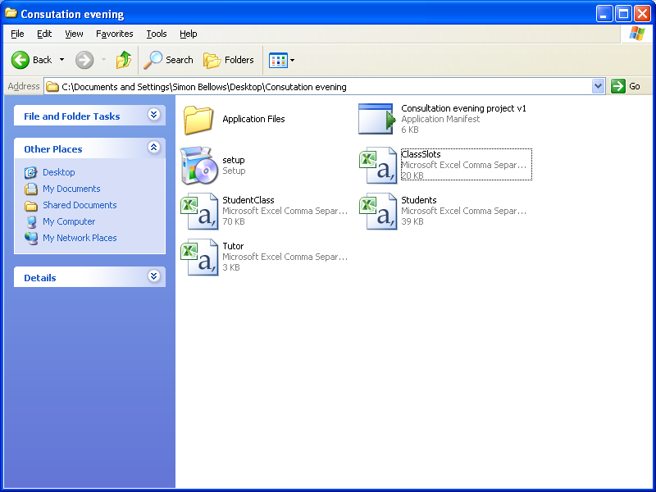

The member admin then just has to click “import staff and student data”

If there is no problems they will get a series of messages telling them that each of the 4 pieces has been imported :

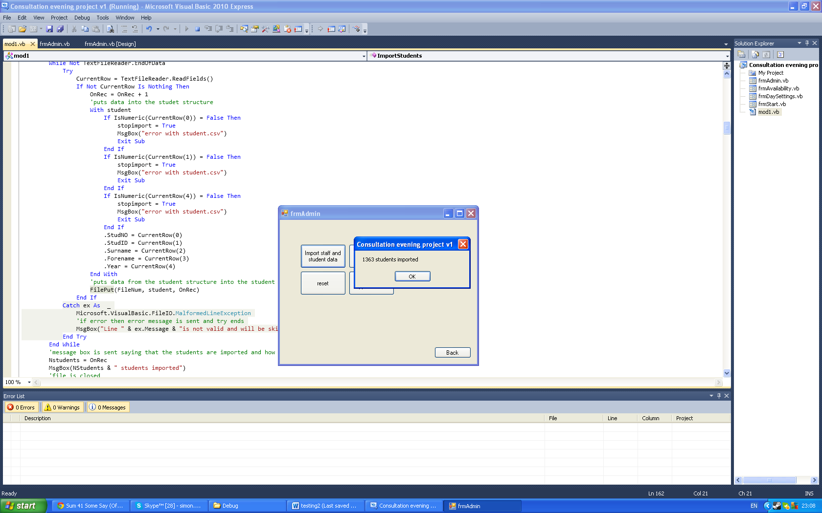

If you forgot to put in the CSV’s a message like this will apear reminding you to do so: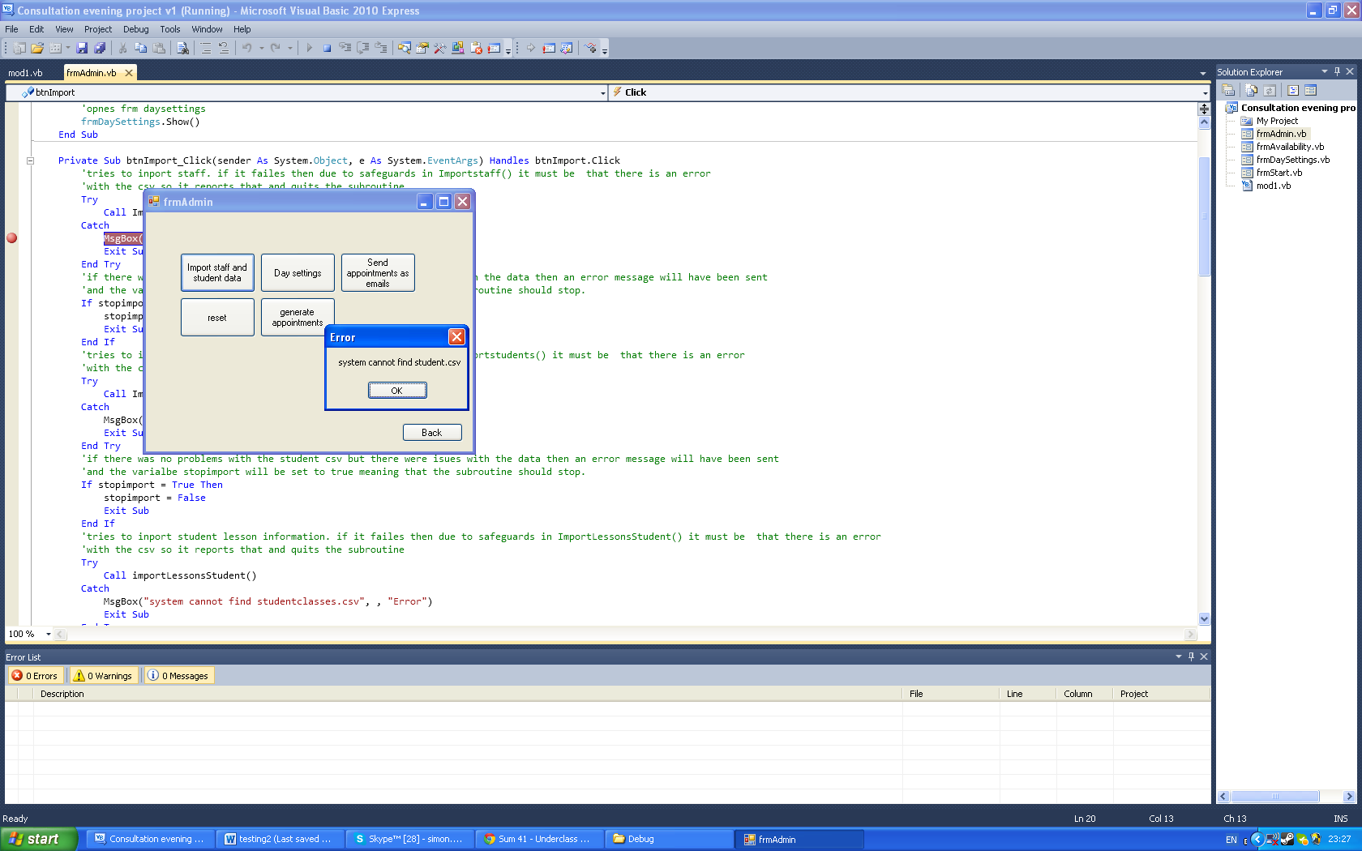

If on the other hand there is problems with the data in the CSV’s then a message like this will appear:

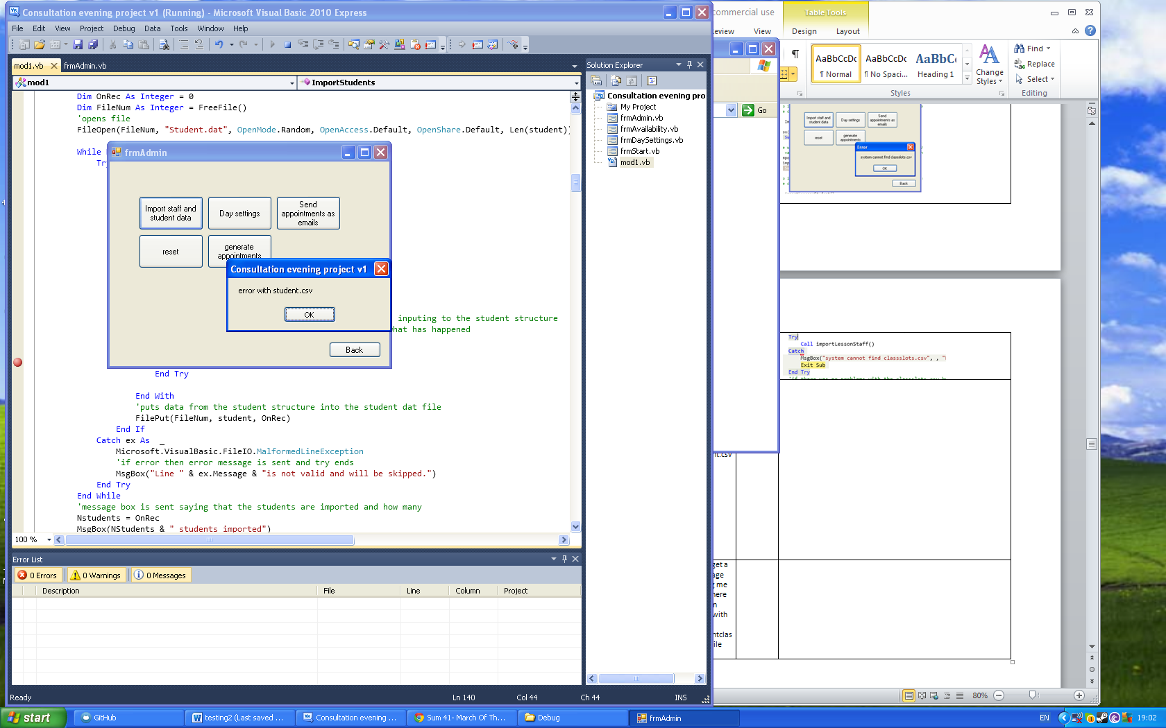

### Setting day settings

Upon clicking the day settings button you will be met with

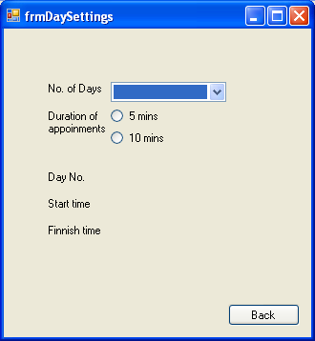

Appointment length is selected via clicking the radio buttons and the number of days is selected by clicking on the desired number in the combo box labelled no of days.

Once this is done the form will look like this

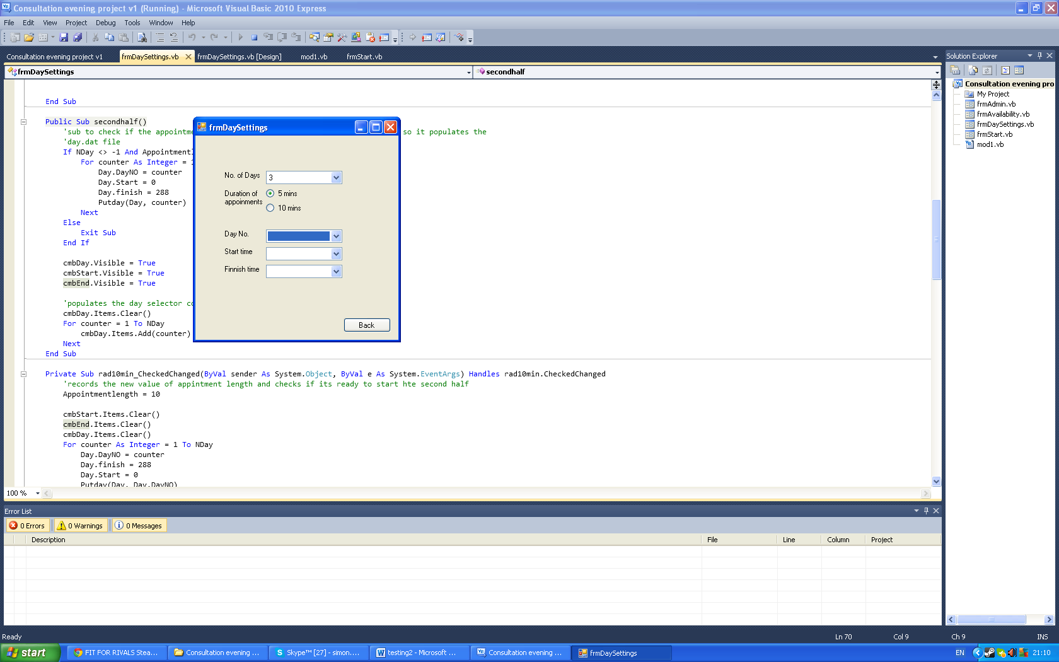

To set the start and finish times for each day first select it on the combo box named day No.

Then pick the desired times from the start time and finish time combo boxes. The form of which will be in 24 hours form. As shown in example bellow

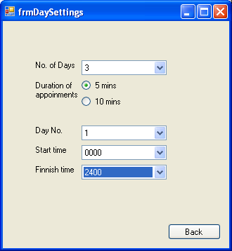

When finished the user should click back to take them back to the admin form

### Resetting DAT files.

Though the easiest way of doing this is probably just to delete them right out of the programs folder the user can also click on the reset button to overwrite all the data in the dat files.



### Generating appointments

This is done simply by clicking generate appointments .



### Sending everyone their appointments

This is done by clicking send appointments as email.

